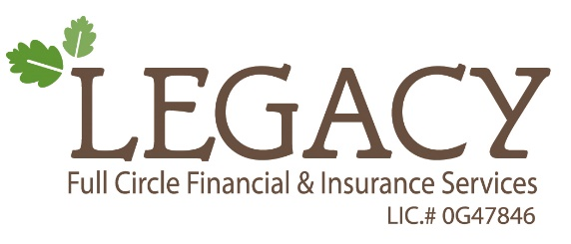

Life Insurance Processing

**Processing step 1: Application is completed and submitted to Legacy Full Circle**

* Emailed to [NewBusiness@legacyfullcircle.com](mailto:NewBusiness@legacyfullcircle.com)
* Or Fax to (213)341-2448
* Or Mailed to 903 N. Grand Ave Covina, Ca 91724
* Legacy reviews application prior to submission to carrier
* Legacy may contact agent for further requirements
* Application in good order is submitted to carrier
* If lab work is needed agent should order lab work when meeting with client to prevent delays.

**Processing step 2: Carrier processing**

* Carrier receives application and begins processing (7-10 business days)
* Carrier provides policy information via your agent portal with that carrier and/or sends email to agent and Legacy Full Circle.
* Carrier provides pending requirements on policy

**Processing step 3: Legacy Full Circle initiated policy processing (7 business days)**

* [Newbusiness@legacyfullcircle.com](mailto:Newbusiness@legacyfullcircle.com) begins to case manage and follow up with carrier on pending conditions (ongoing)
* Agent works with Legacy New Business department to fulfill and submit all pending conditions

**Processing step 4: Policy Issue (times vary)**

* Policy will be issued once all conditions are in good order and fulfilled
* Policy will be mailed by carrier directly to agent
* In order for the policy to be active and paid, carrier must receive the policy delivery receipt to activate the policy and mark it is paid.

For any questions or concerns regarding the life new business submission process, please contact our life new business department.

*(626)214-3013 ext. 100 or Ext 112*

*Fax: (213)341-2448*

[*NewBusiness@legacyfullcircle.com*](mailto:NewBusiness@legacyfullcircle.com)